Indirect Access
Name: jasveena
Student ID: 224001588
Date: 1 -06 -2024

Learning Journey and Evidence

Review pointers, and references.
What did you think while reviewing this in the Programmer’s Guide? Which aspects did you already know, which were challenging? Which explanations helped, which were confusing? Etc.

Pointers: A pointer is a data type built into the programming language. A pointer has a value, that stores the location of another value. The pointer’s value is the memory address of the value it points to this means that we can point to any value in memory, regardless of where it is. A pointer value is the same as any other value it can be stored in local variables, global variables, it can be passed to a function in parameter and it can be returned from a function.
References:. Pointers and references both store the address of another value in memory. They are both used to refer to another value. While in pointer we need to manually get the address and store it in the pointer in reference the compiler takes care of this for us.

What other resources did you use to help understand these concepts? Any good resources you would recommend to others?

I used youtube to deepen my understanding of different headers

Create a small program to demonstrate the use of pointers.
Show your process for this and highlight any realisations you gain.
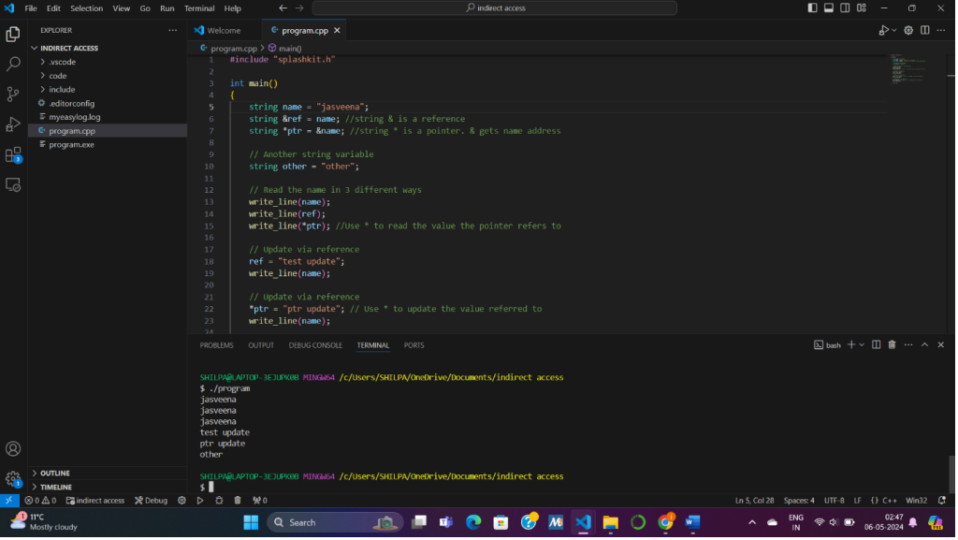
Include a hand execution of the program to explore how it works.
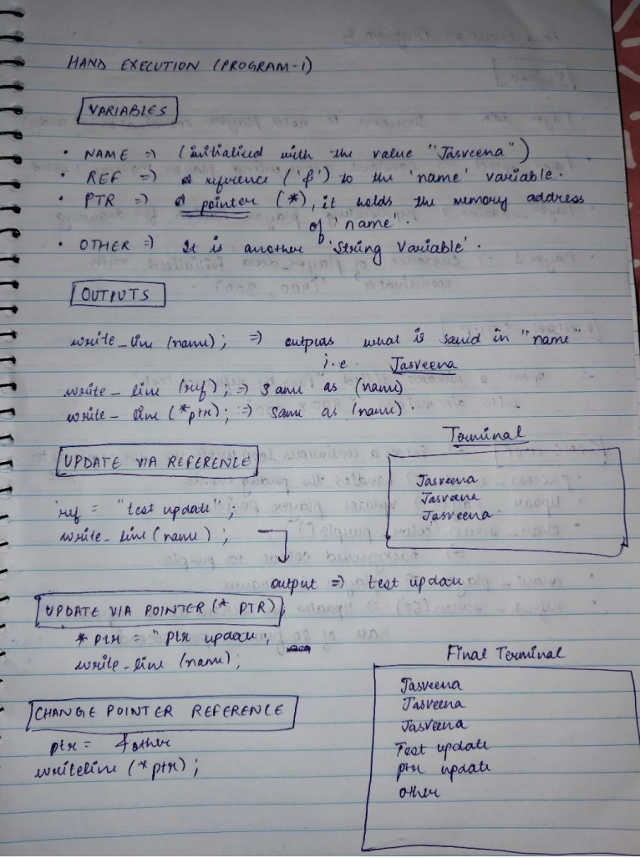

Create a small program to demonstrate the use of pass-by reference.
Show your process for this and highlight any realisations you gain.
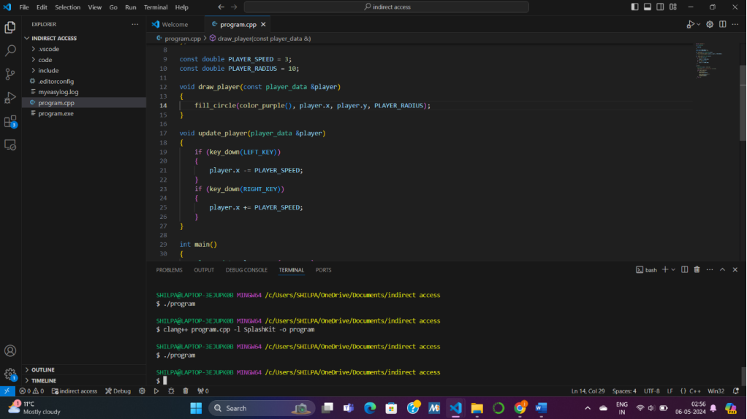
Include a hand execution of one of the calls to swap to explore how it works.

Update your Fly Catch program to make use of pass by reference
Show your process for this and highlight any realisations you gain.
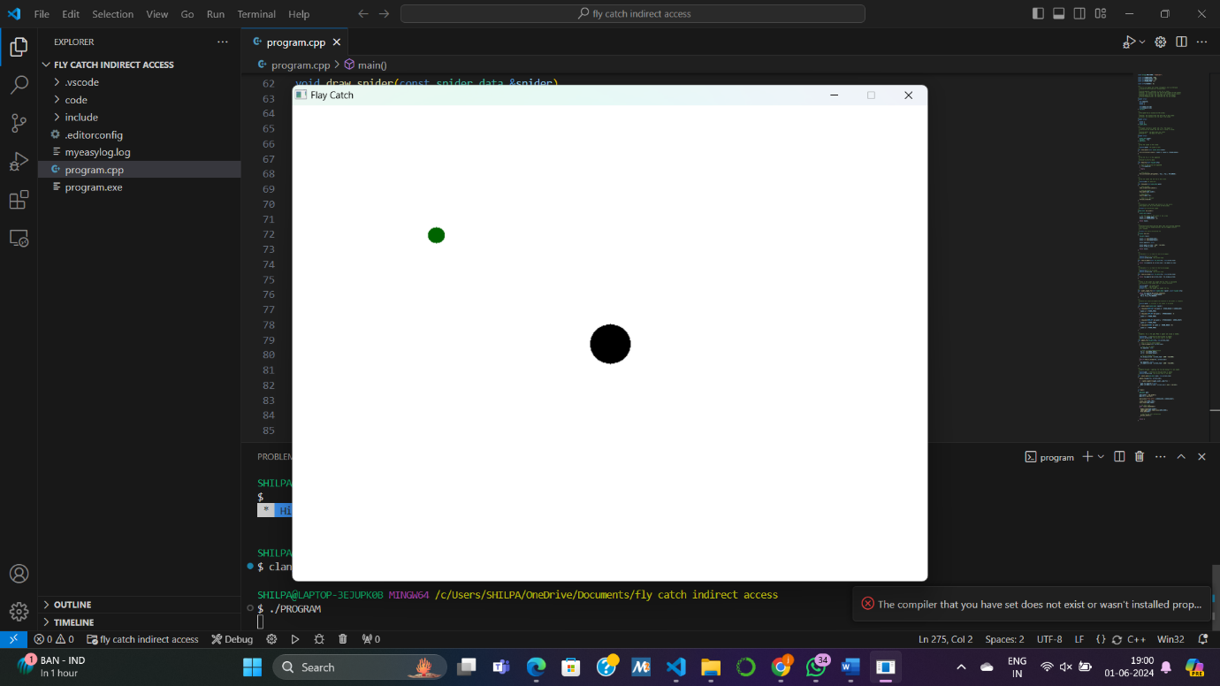

Capture any other study and practice used to master these concepts.
Show evidence of any additional study and practice you did to master these concepts.

Complete one of the Test Your Knowledge activities
Show your process for this and highlight any realisations you gain.
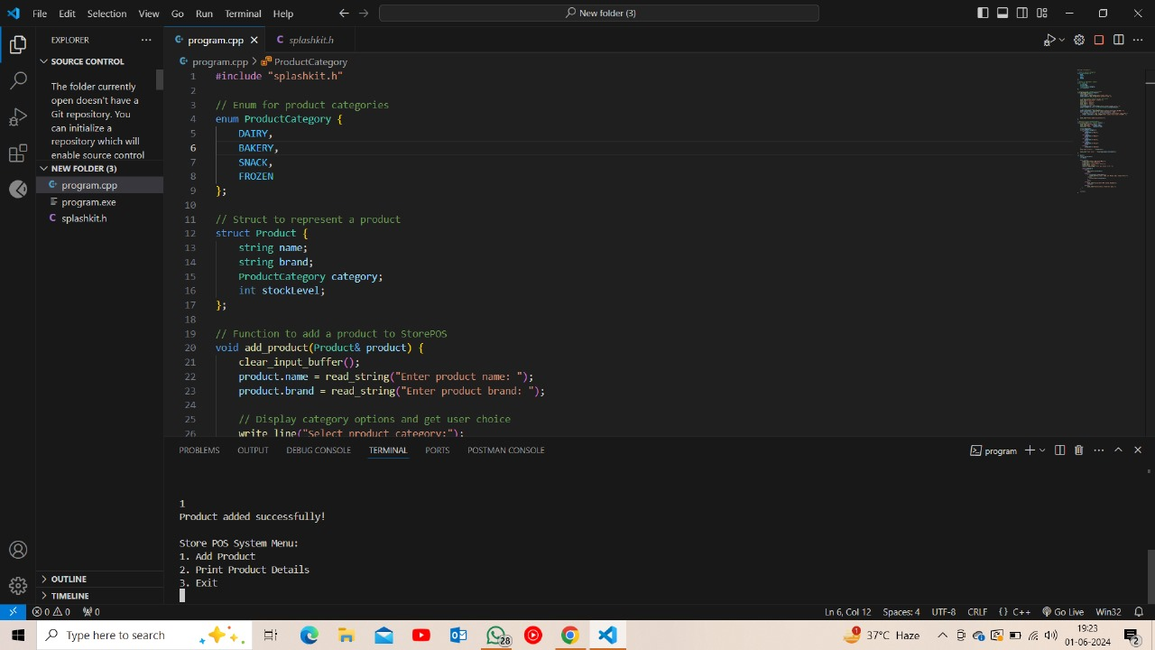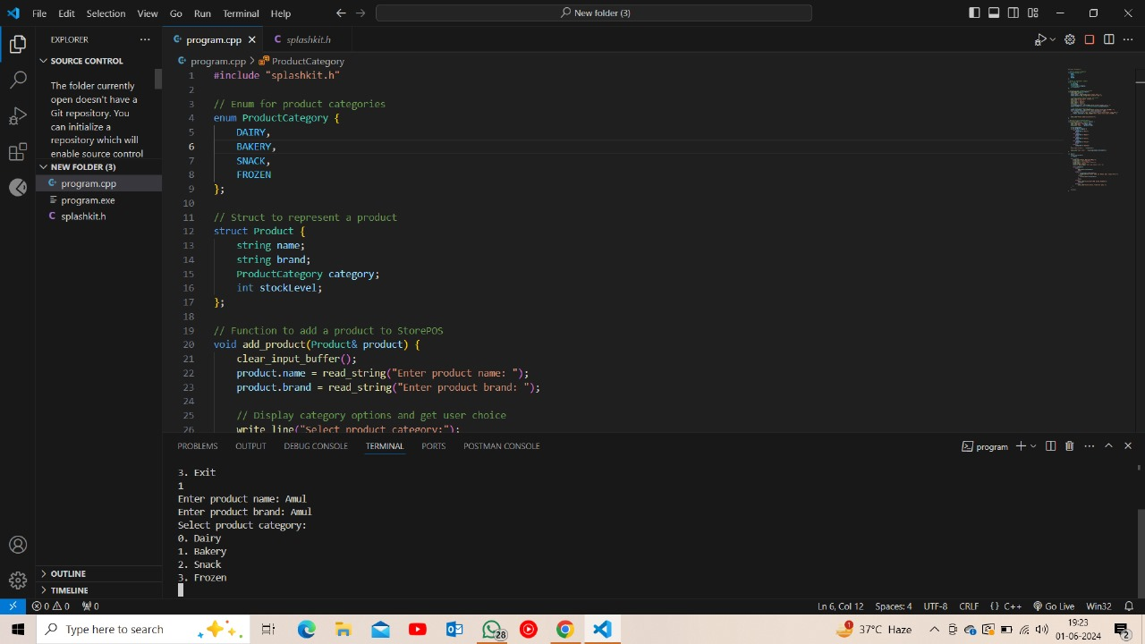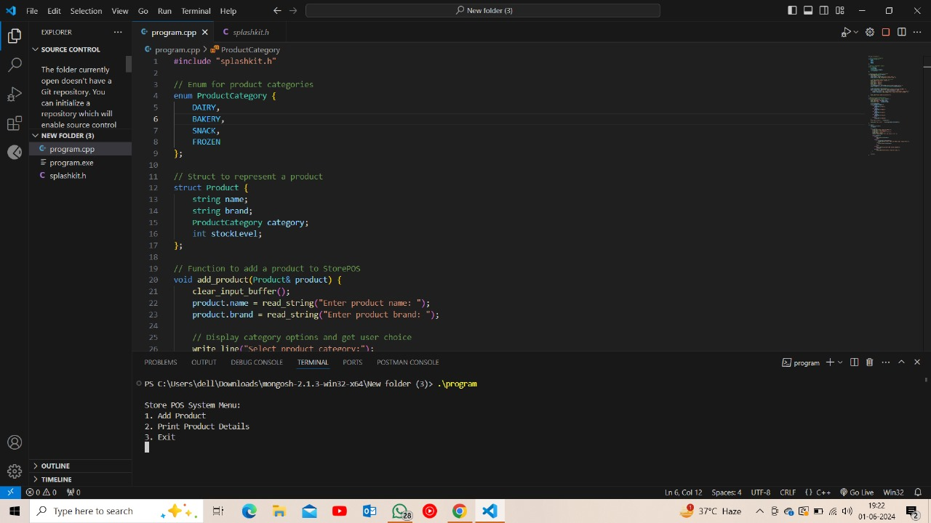

Brief Summary of Concepts
Concept | Key Idea / Concept
Pass by Value vs Pass by Reference | These are the terms that explain how data is passed to a parameter. Pass by value copies value to the parameter while pass by reference is like passing the variable itself to the parameter.
Pointers | It is a datatype built into the programming language
References | While in pointer we need to manually get the address and store it in the pointer in reference the compiler takes care of this for us.
Null | Indicates an invalid or non-binding value or associated with the value 0.
Segmentation Fault | if you attempt to dereference a pointer and perform an action that is not permitted at that location in memory, this will result in a segmentation fault.
Dangling Pointers | Dangling pointer is a pointer that does not point to na valid value.

Reflection

What gives you confidence you have achieved the learning goals?

Use pass-by reference to accept and update values
Passing parameters by reference allows you to modify the original variables passed to a function. I used the pass by reference to accept and update values in the program shown above.

Use const (constant) references to provide read-only access to data to improve performance.
Utilizing const references ensures that the data passed to a function cannot be modified within the function, which can improve performance by avoiding unnecessary copying of data. I Read through the programmers field guide and used it in the small program

Use pointers to refer to and interact with other values in memory.
Pointers are powerful tools for interacting with memory addresses and manipulating data indirectly. By creating programs that demonstrate the use of pointers, we’ll gain a deeper understanding of how they work and their practical applications, such as dynamic memory allocation and data structures.

What is the most important thing you learned from this and why?
The most important thing i learned from this exercise is the fundamental concepts of pointers and references and how they differ in terms of syntax, behavior, and usage. Understanding these concepts is crucial for writing efficient and robust code, especially in scenarios where memory management and performance are critical.

